Me, Myself & Die GDD-Lite

Version History
Version | Date | Changes
0.1 | 1 July | Initial notes
0.2 | 5 July | Fleshed out, initial draft complete
0.3 | 10 July | - Clarifications on laser location  - Hazards & non-hazards listed by importance  - Removed alternate theme concepts
0.4 | 20 July | - Added Unity object placement specifications  - move to tech doc later?  - Added Camera section  - Added Level Design section

Overview
MM&D is an isometric level-based puzzle game with an Egyptian theme.
The player must orchestrate their death in specific locations, then use the resulting corpse-blocks as steps and bounce-pads to reach each level’s exit.

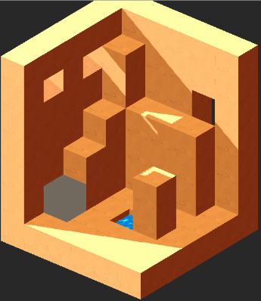
Camera
Isometric, Fixed, Diagonal
- Mounted slightly off the diagonal to prevent complete obstruction of hidden areas
  - Angle currently 30, 230, 0
  - Perfect diagonal would be 225, not 230
Level Transitions
- Current level rotates away clockwise on Y to bring in new level
- Lighting remains fixed relative to scene

Loop
Move -> Die -> Respawn, leaving corpse-block at site of death
Move -> climb onto / bounce off corpse-block -> Reach exit -> Next level

Core Mechanics
Corpse-Blocks
Each time the player dies, they leave a corpse-block at that location. Respawning at the start of that level, the player can then use these corpse-blocks:
as Stairs
- Player can climb onto corpse-blocks as they would any 1-high block
- Useful as stairs to access areas that are 2-high
as Bounce-Pads
- If player falls onto a corpse-block from any height, they bounce
- Bounce moves player 2 upwards & 1 forwards in the direction of travel

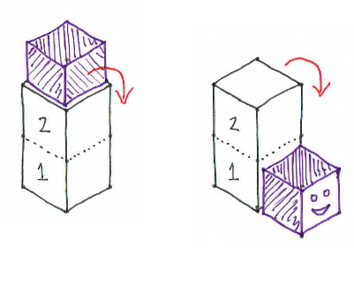
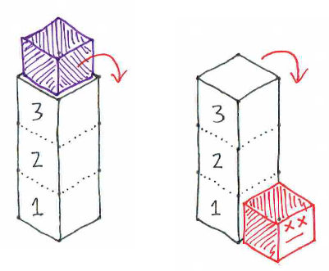
Hazards
Fall from 2-high block is safe
Fall from 3-high block is lethal
The player can use these hazards to orchestrate their death.
Falling (essential)
- Falling from height 3+ onto a surface kills the player
Static Hazard (essential)
- Occupies a ground-tile
- Entering the tile kills the player
Water (high importance)
- Occupies a ground-tile
- Functions as a static hazard, but leaves no corpse-block
  - Existing corpses still increment
  - Can be used by the player to ‘reset’ the level
Laser (essential)
- Beam from an emitter embedded in any wall, ceiling, or pillar (N-high block)
- Beam covers a line of tiles until it collides with a wall, push-block, or corpse
- Tiles beyond the point of collision are not covered by the laser, even if they were previously
- Entering any beam tile kills the player

Non-hazards
These objects may appear in levels, but do not directly harm the player.
Fan (high importance)
- Set into a wall or pillar
- Shunts the player, corpse-blocks, and push-blocks along a line until they hit something
Piston (low importance)
- Set into a wall, floor, or pillar
- Extends across a set number of tiles
- Shunts the player, corpse-blocks, and push-blocks that enter these tiles
Push-Block (moderate importance)
- May be moved around by the player
  - If the player moves from an adjacent space towards the push-block, the push-block is shunted ahead of the player
  - If the push-block is prevented from moving by another object in its path, the player will climb on top of it instead

Level Design
Area
- 5x5 to 7x7 grid
- Level height either always 6, or always N+1
Technical
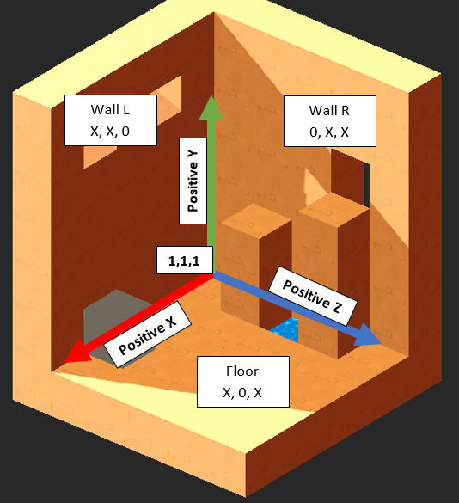

Controls
Movement
Put screen diagram here, indicating quadrants/directions
- Tap in screen quadrants or swipe in any direction
  - Player moves into empty space
  - If target space is occupied by a 1-high object, player climbs on top of it
  - If target space is occupied by a 2-high object or higher, movement in this direction is not possible

Theme
See Art Bible for actual detail.
Egyptian Sandstone
Terrain Sandstone blocks
Player Alien cube
Fan Portal-style beam?
Static Fire
Water Water-pit
Laser Laser-crystal, possibly emanating from scarab housing?

